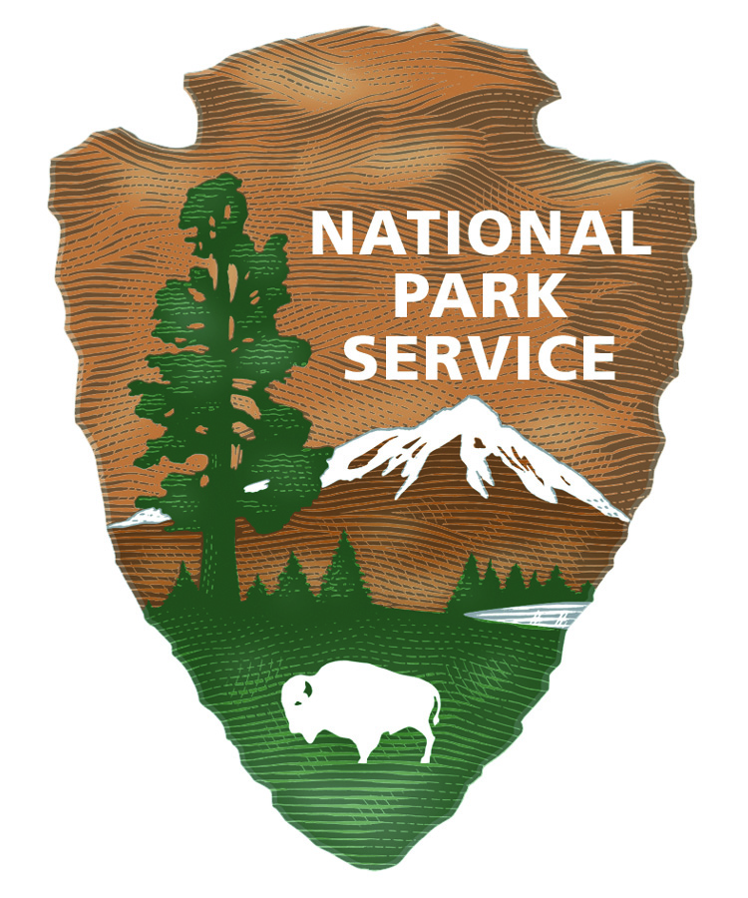  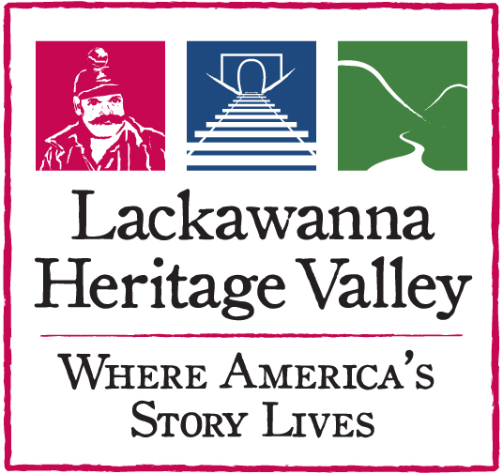 | Lackawanna Heritage Valley  National and State Heritage Area  213 Railroad Avenue, Scranton, PA 18505  Phone: 570.963.6730 x8200  Partnership Grant Application  Fall Round 2025  (Applications are due September 15, 2025) |  |  | LHV Use Only  Received _____________  Accepted ___  Denied ___  Modified ___  Amount ______________  Initials _______________
General Information: Before completing this application, please contact April Rogato, LHV Executive Assistant, at 570.963.6730 x8200 or arogato@lhva.org to discuss your project.
Instructions:
1. Please complete all the sections. An electronic (email) copy and a printed (paper) copy, signed by an official, are required.
2. Electronic (email) completed application is to be sent to arogato@lhva.org.
3. Printed (paper) completed application must be signed by your organization’s authorizing official (Executive Director, Board of
Directors Chairperson, President, etc.)
This application may be sent by postal mail or hand delivered to the above address.
APPLICANT: (Name of organization/agency managing the project) |  |  | **FEDERAL EMPLOYER I.D. NO.:  **DUNS NO:
APPLICANT MAILING ADDRESS: (Street, city, state, zip) |  |  | PHONE NUMBER:  FAX NUMBER:
PROJECT COORDINATOR: (Name and title of person managing project) |  |  | EMAIL ADDRESS:  PHONE NUMBER:
TYPE OF ORGANIZATION: (Check one)  ___ Government Entity ___ Non-Profit Org. ___ Educational Institution |  |  | WEBSITE:
PROJECT TITLE:
PROJECT START DATE: |  | PROJECT END DATE:
AUTHORIZING OFFICIAL: (President, Chair, etc.—the head of the applicant organization who signs below)

PROJECT LOCATION: (Municipality(s) and County(s))

BRIEF PROJECT DESCRIPTION: (Please limit description to 200 words)

SUMMARY OF ESTIMATED PROJECT COST/GRANT REQUEST (Complete worksheets on pgs. 3 & 4 first)
 | A. | $ |  | IN-KIND/VOLUNTEER SERVICES DONATED
 | B. | $ |  | CASH PROJECT COSTS
A+B = | C. | $ |  | TOTAL PROJECT COST (How much it will cost to do your project, including any In-kind donations)
 | D. | $ |  | AMOUNT YOU ARE REQUESTING FROM LACKAWANNA HERITAGE VALLEY
 | E. | $ |  | AMOUNT OF TOTAL MATCHING FUNDS (cash, earned income, other grants, etc.)
Signature of Authorizing Official ____________________________________ Title ___________________ Date _____________

2. Project Scope

Write a clear project description that answers the following questions (individual sections will expand as you fill them in):

- What is/are the goal(s) and purpose of this project?

- Who is the intended audience?

- How do you intend to measure whether or not your goals have been attained?

- Describe the process you will use to ensure public participation.

- What is the project timetable (list phases and when you intend to start and complete each)?

3. Funding Goals of the Lackawanna Heritage Valley National and State Heritage Area

Please explain how the project will relate to or enhance the five goals of the Lackawanna Heritage Valley National and State Heritage Area (see below). If the project involves a partnership effort, supplemental documentation should be included that verifies partner support (resolutions or letters from participating partners). In explaining the impact the project will have on the local and regional economy, please address factors such as attraction of tourists, job opportunities, small business development, revenue projections, public/private investment partnerships, etc.

- Facilitate partnerships and strengthen local capacity.

- Tell the story of the Lackawanna Heritage Valley.

- Preserve and enhance the physical character and economic vitality of Heritage Valley Communities.

- Improve the visitor experience.

- Reconnect communities and people to the Lackawanna River.

4. Public Use/Non-discrimination

All programs, projects and/or events funded by LHV must provide a public benefit, which shall not discriminate on the basis of race, religion, handicap, color, national origin, sex, or age. Please describe below how this requirement will be met. Feel free to attach a copy of your organization’s non-discrimination policy.

5. Cost Estimate/Budget Worksheet

Using the tables below, provide a cost estimate to complete the project. The cost estimate should indicate which work items will be paid for in cash and which will be completed through in-kind or volunteer services. LHV funds require a dollar-for-dollar match of public or private monies — or a combination of the two. LHV grants cover no more than fifty percent (50%) of direct project costs. After you complete each budget table, transfer the total to the appropriate lines on page one as instructed. For complete instructions, please refer to Grant Seeking Guidelines for Partnership Grants at https://lhva.org/PartnershipGrants.php . Add rows to the tables as necessary.

5a. In-Kind / Volunteer Services (Line A on page one)
In-kind contributions are non-cash donations for the project contributed by the applicant or by a third-party. In-kind and volunteer services cannot be counted as part of the required cash match for a grant. (Add rows as needed.)
Description of Donated Goods or Services |  | Amount
TOTAL OF ALL DONATED GOODS & VOLUNTEER SERVICES Put (Line “A” on page 1)

5b. Matching Funds (Line E on page one)
NOTE: You will need to verify all Matching Funds when the project is completed and you submit the Final Report, so only list matching funds for which you believe you will have documentation.
Matching Funds include money raised for the project by the applicant through sources such as grants and earned income. Applicants must demonstrate a dollar-for-dollar cash match for all funds requested from LHV. Public Matching Funds include financial support from government agencies. Private Matching Funds are monies from non-governmental organizations or agencies, including cash donations and estimated earned income. (Add rows as needed.)

List All Matching Funds.
Source | Amount | Note whether the  source is: Federal, State, or Local Government;  or Private | Are the funds: In Hand, Applied For,  or Pending

TOTAL OF MATCHING FUNDS

(Line “E” on page 1)

5c. Project Budget.
Detail the project’s total estimated eligible costs by type and dollar amount. Include calculations if necessary. Add extra lines if needed. Documentation of all expenses, including invoices and proof of payment, must be included with Final Report.
Description of Expense | LHV Requested Amount | + | Applicant Match | = | Totals
 |  | + |  | =
 |  | + |  | =
 |  | + |  | =
 |  | + |  | =
 |  | + |  | =
 |  | + |  | =
 |  | + |  | =
 |  | + |  | =
 |  | + |  | =
 |  | + |  | =
 |  | + |  | =
 |  | + |  | =
 |  | + |  | =
TOTALS |  | + |  | =
 | Include total on line “D” on page 1. | + | Include total on line “E” on page 1. | = | Include total on line “B” on page 1.

Rev. 8/10/25

